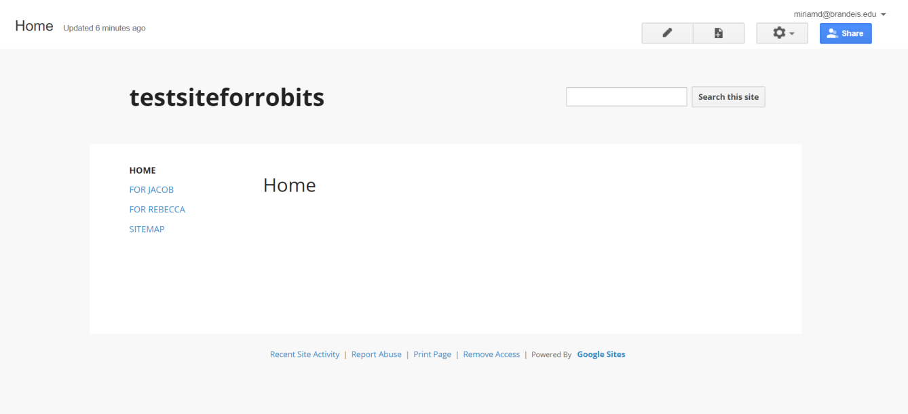

Devora Krischer 4/14/19 USER INTERFACE:

Created skeleton website via Google sites.

The website is meant to allow each member to access a specific page through their Google account. It is currently a proof of concept and contains only two pages and a home. Each page can be accessed by one person.

The website can be used to store text files and other information, as well as to provide public documentation of the project

The next steps are to add pages for the members of the team and to find a way to connect the robot to the site.

How to use page level permissions:

<https://sites.google.com/a/whps.org/google-sites/tutorials-videos/page-level-permissions>

How to upload files:

<https://support.google.com/sites/forum/AAAATAKBXDQxHCDM4LZyHY/?hl=en&gpf=d/topic/sites/xHCDM4LZyHY>

How to make private pages:

<https://support.google.com/sites/forum/AAAATAKBXDQbOfna9nP40Y/?hl=en&gpf=d/topic/sites/bOfna9nP40Y>

Google Sites:

[https://sites.google.com](https://sites.google.com/)

Link to the site itself:

<https://sites.google.com/a/brandeis.edu/testsiteforrobits/>

Credit to Timothy Hickey for knowledge of Google sites

Future work: Coordinate with Matt and Joy

Let the user upload documents and the robot connect to it (ideally this website would be able to do both)